

|  |
| --- |
| defjkefijffkeifhknfdwkhfwhf |
| **WILSON SPORTING GOODS**  ***E PROJECTS “SPORTING GOOD”*** |
| |  |  |  | | --- | --- | --- | | Wilson Sports and over team | 4/4/22 | www.Wilson Sports.html | |

mdfjf

|  |  |  |
| --- | --- | --- |
| Hhz HADI ABBAS | 1339583 | PR2-202110E |
| DAWOOD USMAN | 1349975 | PR2-202110E |
| AYESHA USMAN | 1349978 | PR2-202110E |





HADI ABBAS, DAWOOD USMAN**, AYESHA USMAN**

**CERTIFICATE OF COMPLETION**

Date

Has successfully completed Course of Study

Signature

***eProject: Wilson Sporting goods***

WILSON SPORTING GOODS

|  |  |  |
| --- | --- | --- |
| Faculty. | Miss Aeliya Naqvi | |
| Batch. | PR2-202110E | |
| Serial No. | Enrollment Number | Student Name |
| 1. | 1339583 | Hadi Abbas |
| 2. | 1349975 | Dawood Usman |
| 3. | 1349978 | Ayesha Usman |

***eProject: Wilson Sporting goods***

ACKNOWLEDGEMENT

The first, we would like to express my special thanks of gratitude to my teacher <<Miss Aeliya Naqvi>>, who helped us a lot in finalizing this project within the limited time frame, valuable counselling and assistance for the accomplishment of this project.

Secondly, we would also like to thank the e Project team at Aptech Head Office, who gave us the golden opportunity to do this wonderful project about Aura Watch.

Thirdly, we also thank the e projects team, some of the benefits are as under:

* Re-enforcement of skills happens in the experiential learning process.
* A mentor, ensuring that we do not get drifted, constantly guides us.
* It gives us a lot of confidence to face an interview as we have worked on a project. We can explain virtually everything on the subject we have learnt.

***eProject: Wilson Sporting Goods***

# SYNOPSIS

Follow the strong development of the internet, technology Sports and the growing watch market, every business needs a website design to display products on the internet.

The following Sports product are designed with many different designs, suitable for all styles and preferences, which are the most special suggestions from Sports Products.

Attached are the introductions hidden behind the Sports gift from the gift you want to send to good Company, colleagues or loved ones , And send to products to Companies.

So, Sports Goods shares the best product images through the website for everyone to know.

**WILSON SPORTING GOODS**

is selling various types of Sports Goods. The company advertises by distributing the pamphlets, advertising on television and so on. Due to rapid development in internet field, the company decides to launch a website where people will get all the information about the various products available with them easily.

However, purchases are not made directly on the website.

***eProject: Wilson sporting goods***

# PROBLEM DEFINITION

Wilson Sporting good is into business of manufacturing and selling Sporting goods. They have been advertising about their Sports and Sports Products through newspapers, pamphlets, television. Now with changing times, they have decided to go online as customers today use Internet extensively. They have planned for a website with complete details about their products and sporting goods.

WILSON SPORTING GOODS :

is selling various types of Sports Goods. The company advertises by distributing the pamphlets, advertising on television and so on. Due to rapid development in internet field, the company decides to launch a website where people will get all the information about the various products available with them easily.

So, we solved many particular queries as followed:

* How the sitemap possibly looks alike?
* What information should be displayed on each page?
* How to put every comment is friendly?
* How to give users the best experience when using the website?
* How to let the website properly functioning along with the system requirement?
* Will the user be able to contact with Wilson Sporting Goods company for advice?

***eProject: Wilson Sporting Goods..***

# CUSTOMER REQUIREMENT SPECIFICATION (CRS)

After discussion, we are supposed to create a website for them with the below mentioned requirement specifications:

**Requirement Specification:**

The Web site is to be created based on the following requirements.

1. **The Home Page should be created with proper sections and with a suitable logo.**
2. **Home Page should contain details of Sports Goods with suitable images. The site should display a menu which will contain the options for brief introduction about the various sporting goods available, location of the shop and any other information if required.**
3. **The information should be categorized according to the brand names of the products like if a User wants to see only “REEBOK” products or any other companies products then he/she can click on a Link/button/menu etc and can see only that Brand products.**
4. **When a user selects any particular brand, a list of products for that brand will be displayed**
5. **A brief summary of features of individual products should be displayed on the Web Page along with the product but detailed Features should be stored in Individual Word documents which can be downloaded or viewed by the User who wishes to see the same.**
6. **The user should also be able to compare the various products of different as well as similar brands.**
7. **There should be a “Contact Us” page which will have the Address of the Company which is as follows and the mail address which when clicked will invoke the local mail client from where they can send an email.**

***eProject: Wilson Sporting Goods***

# SCOPE OF THE WORK (IN BRIEF)

The website is to be developed for the Windows Platform using HTML5, JavaScript and Geolocation. The site should work well in all leading browsers including Chrome, IE, and Firefox etc...

Homepage show Top best sell items, big sale, collection, new shop... Every content direct to relative content.

**Hardware:**

* A minimum computer system that will help you access all the tools in the courses is a Pentium 166 or better
* 64 Megabytes of RAM or better

**Software:**

* Notepad/HTML editor
* Dreamweaver
* IE 5.0/ Netscape 6.0

***eProject: Wilson Sporting Goods***

# AGGREGATED SITEMAP

***HOME***

(0.Welcome.html)

Aboutx.html)

***eoroject: Wilson Sporting Goods***

# SITEMAP ENGLISH



A NAVIGATION ura White Watch (Products-Q-1.html)

Aura Embossed SECTIONS

HOME  
ABOUT  
 Watch

(Products-Q-2.html)

Antique Flower Watch (Products-Q-3.html)

SECTIONS

TESTIMONIALS  
bossed Watch (Products-Q-4.html)

A SECTIONS

GALLERY

ura White Acrylic Watch

(Products-W-1.html)

A SECTIONS

PRODUCTS y Dial Watch (Products-W-2.html)

S LOGO (Products-W-3.html)

ABOUT US  
OUR Team y Tone Watch (Products-W-4.html)

CONTACT US(MAP) (Products-A-1.html)

PRODUCTS OF SPORTS

atch Set (Products-A-2.html)

NAVIGATION

SECTIONS

SECTIONS

Aura Embossed Watch

(Products-A-4.html)

Wilson Sporting Goods (2.Product.html),(Contact us .html)

Wilson Sporting Goods (2.About.html)

Wilson Sporting Goods (2.Index.html)

***HOME*** WatcHHOmehes English

(1.Index.html)

ABOUT

(1.Index.html)

**Products**

PRODUCTS

**Page**

(2.Products.html)

Pa TESTIMONIALS

Testimonials

(3.Technology.html**)**

**Store Lo** GALLERY **cator Page**

(4.Store_Locator.html)

CONTACT US

**port Page**

(5.Support.html)

**R** HOW TO CONTACT (MAP)**egister Page**

(6.Register.html)

***eProject: Wilson Sporting Goods***

# WIREFRAMES

1. Main Layout

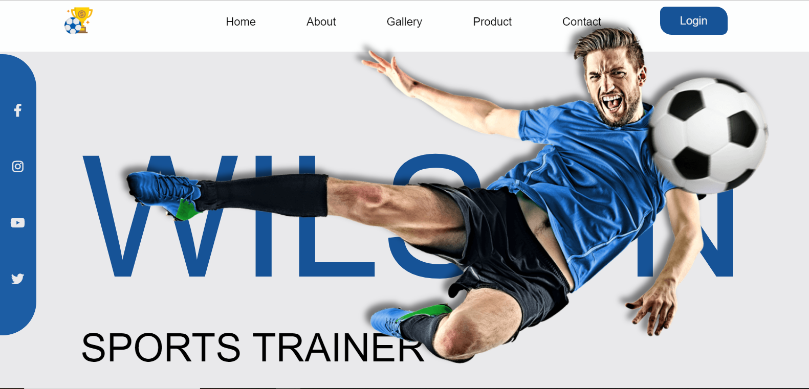

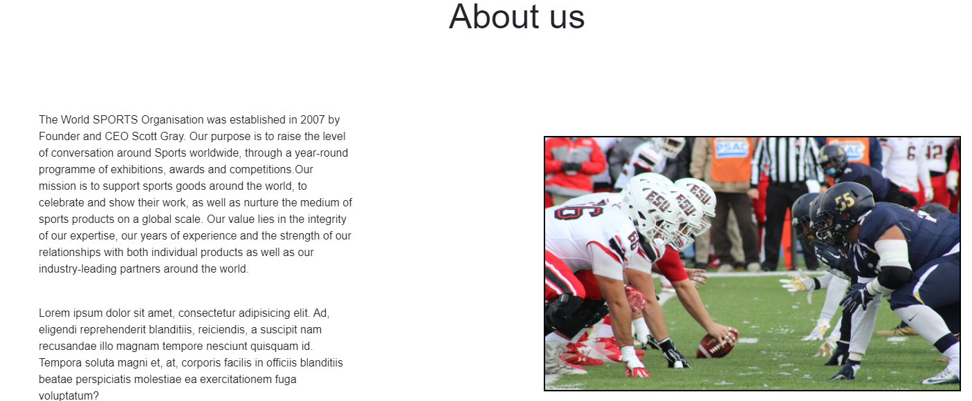

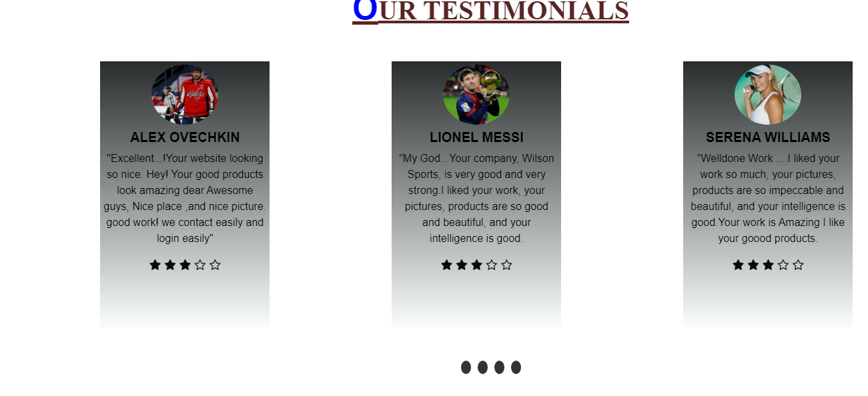

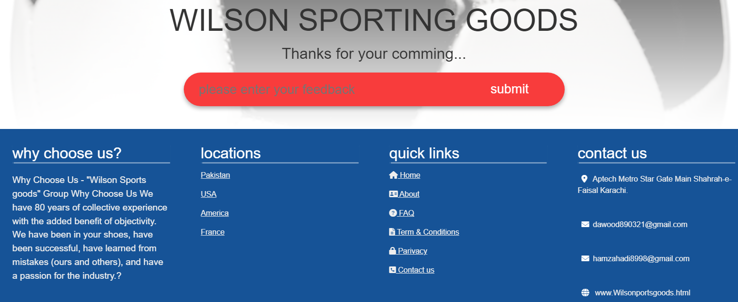

**3**

***eProject: Wilson Sporting Goods***

1. Home Page (**1.Index.html**)

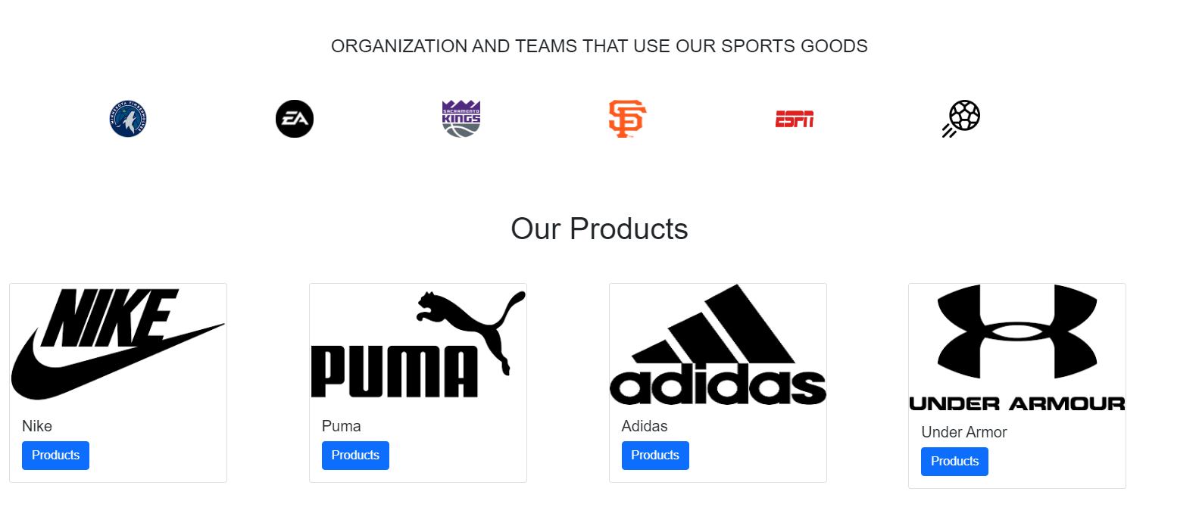

***eProject: Wilson Sporting Goods***

1. About Page**(****2.About.html**)

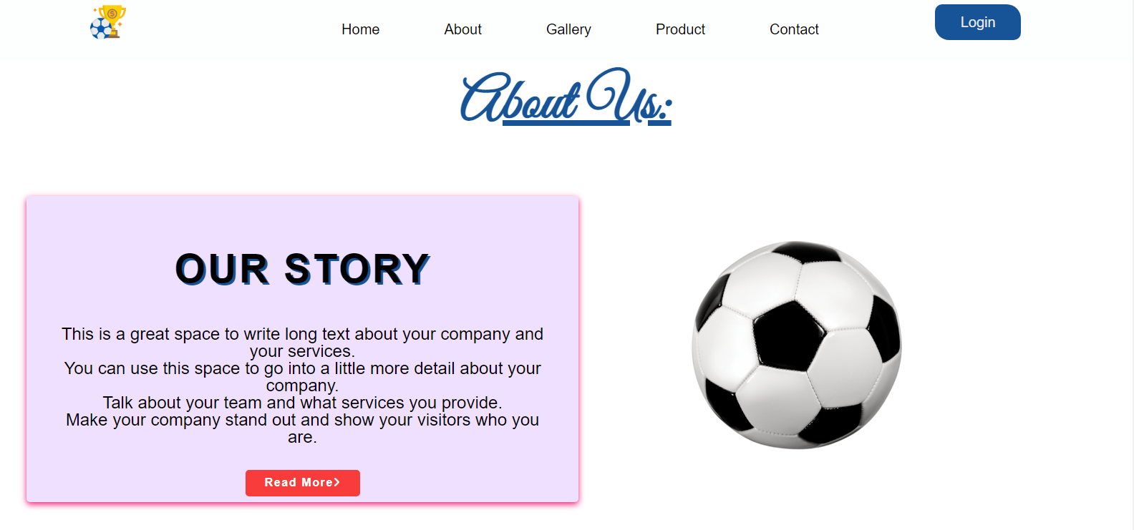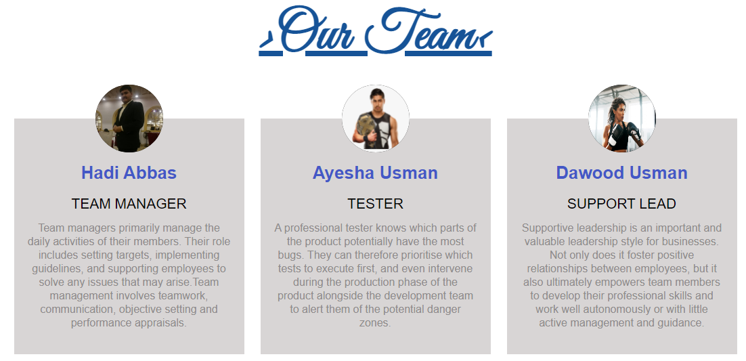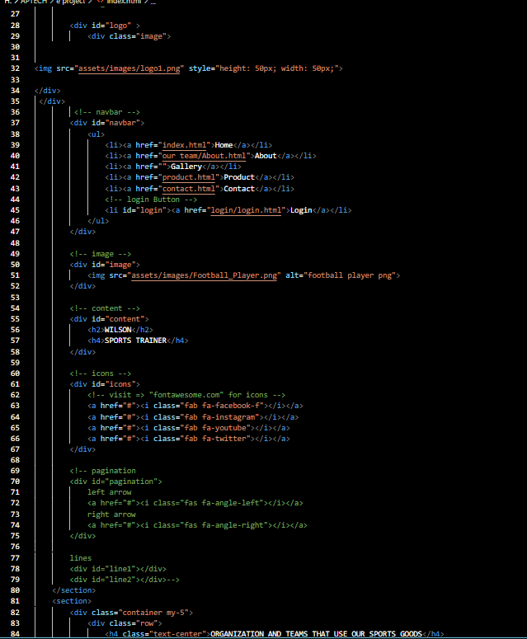

HOME PAGECODINGS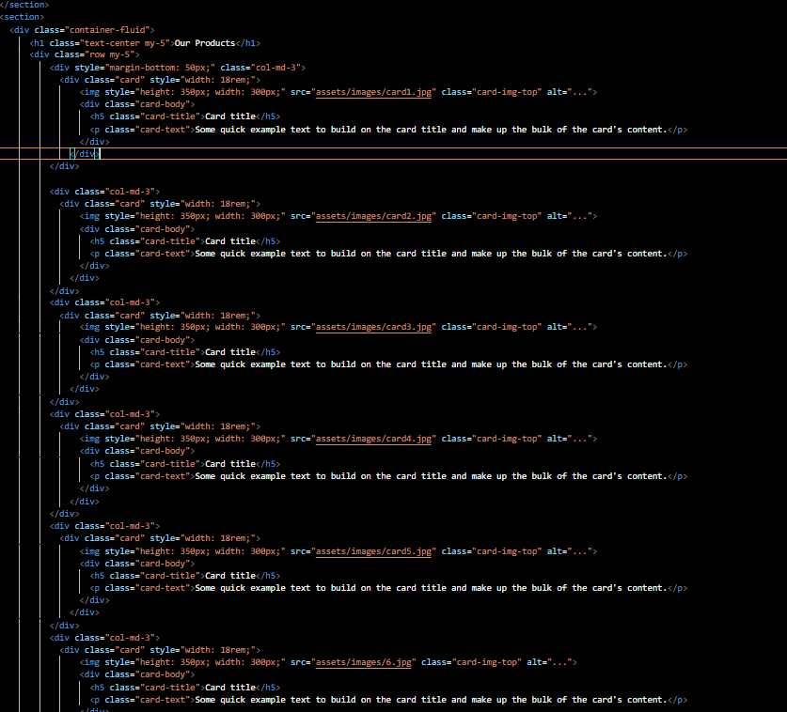

HOM PAGE CODING

***eProject: Wilson Sporting Goods***

4. About Page **(****2.About.html**)

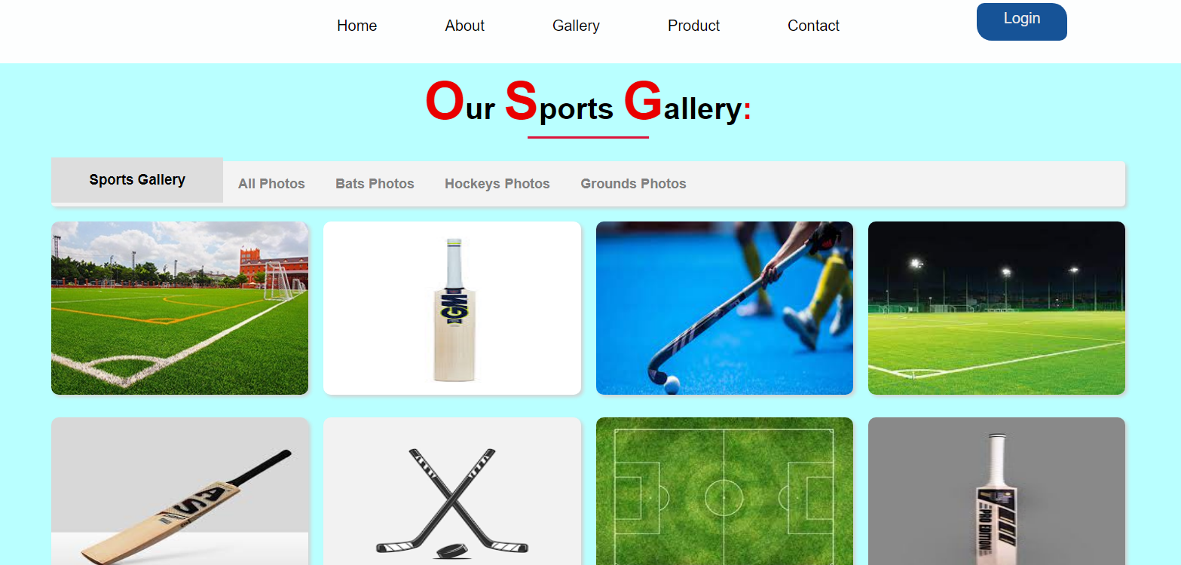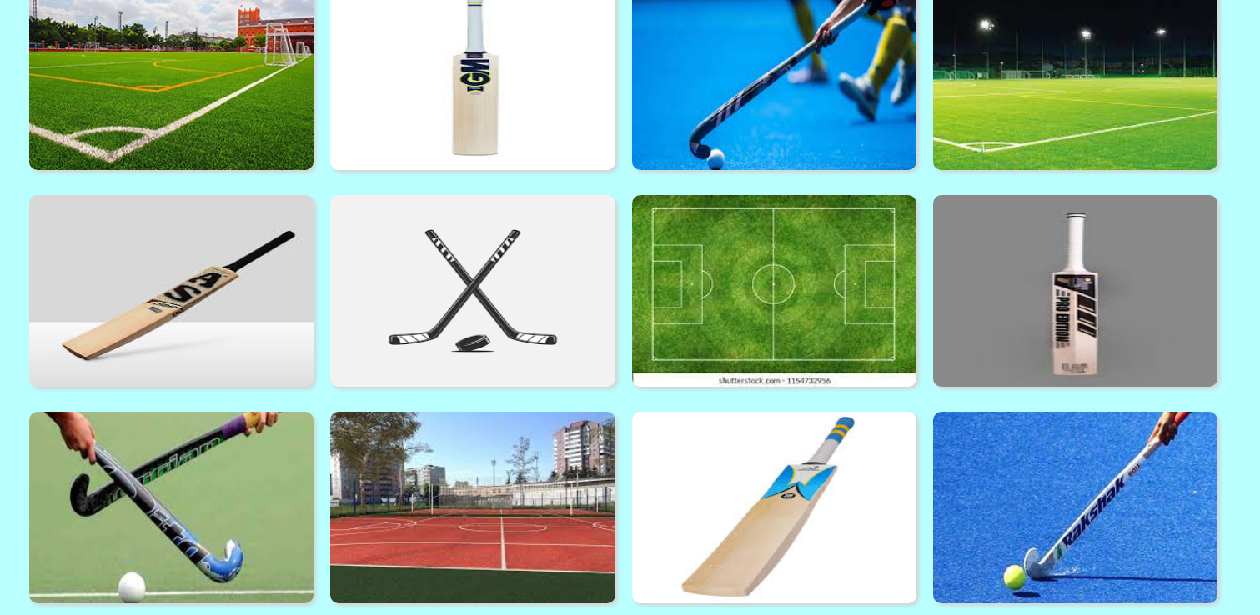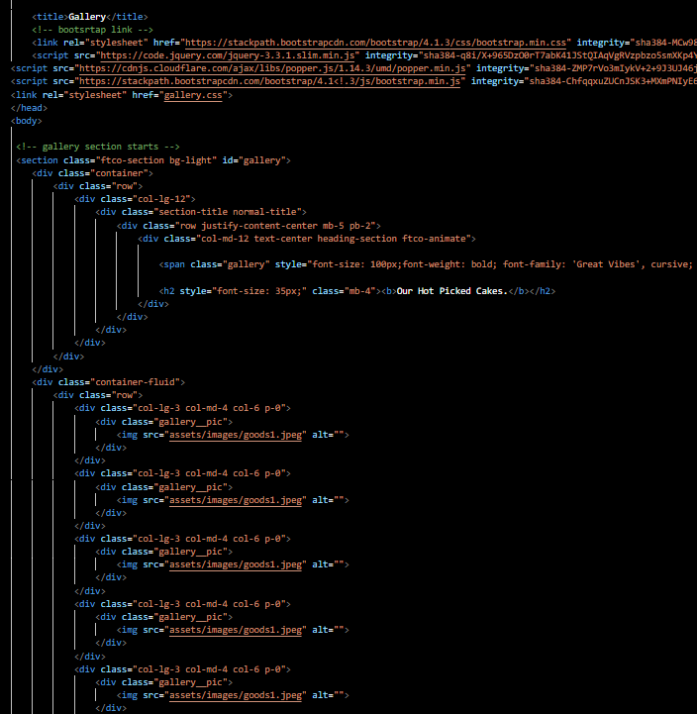GALLERY PAGE CODING

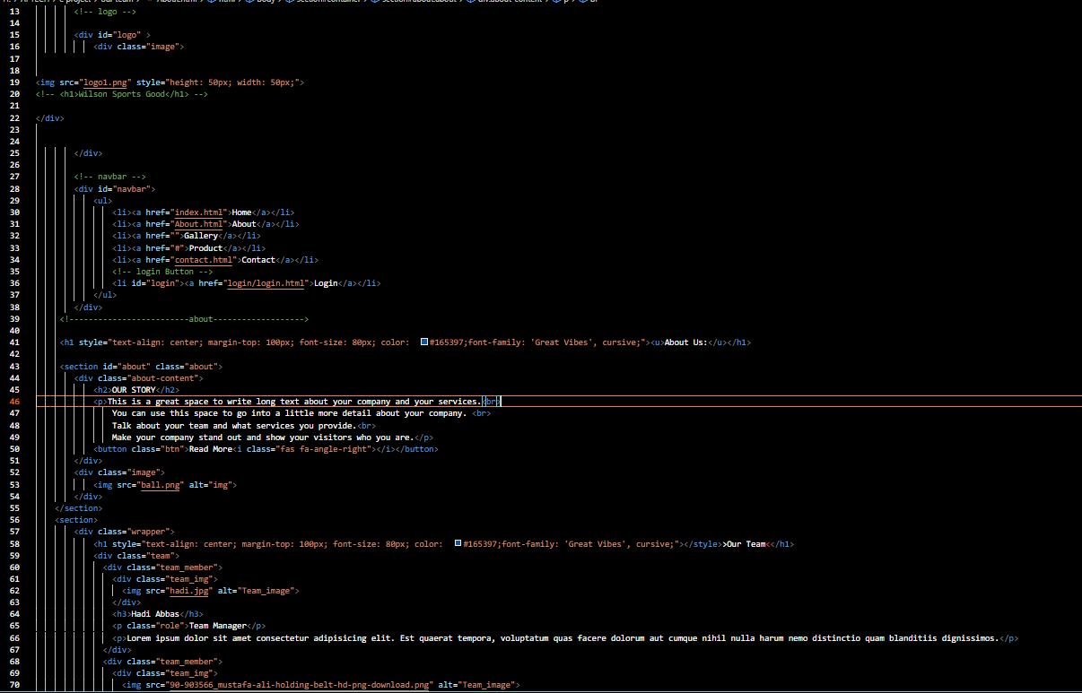

ABOUT US CODING

***eProject: Wilson Sporting Goods***

8

***eProject: Wilson Sporting Goods***

1. Products Page (**3.Product.html**)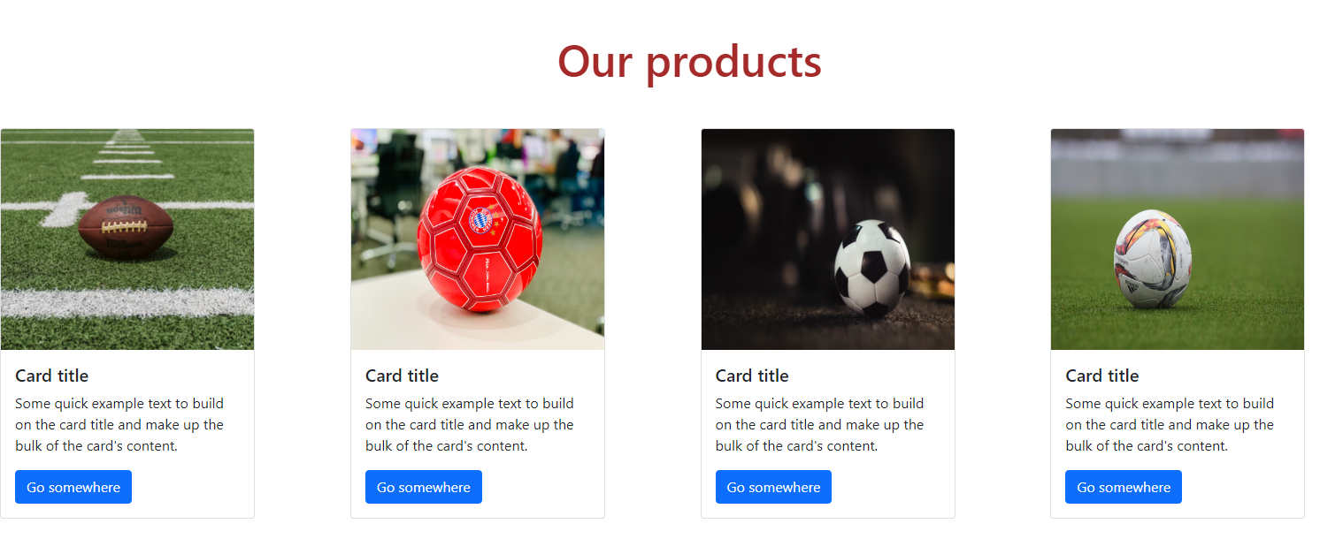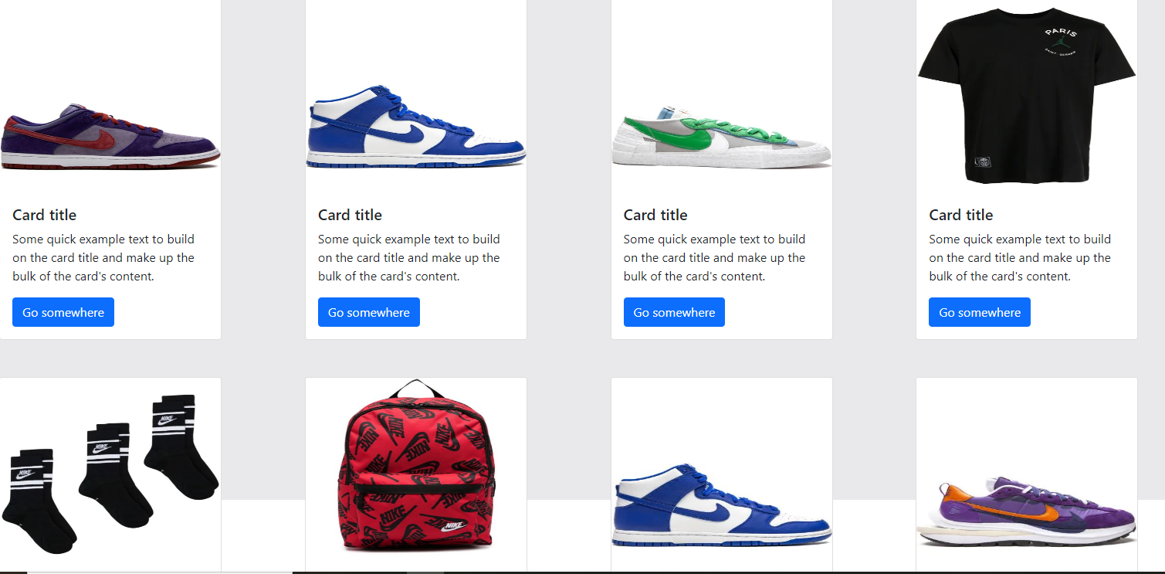 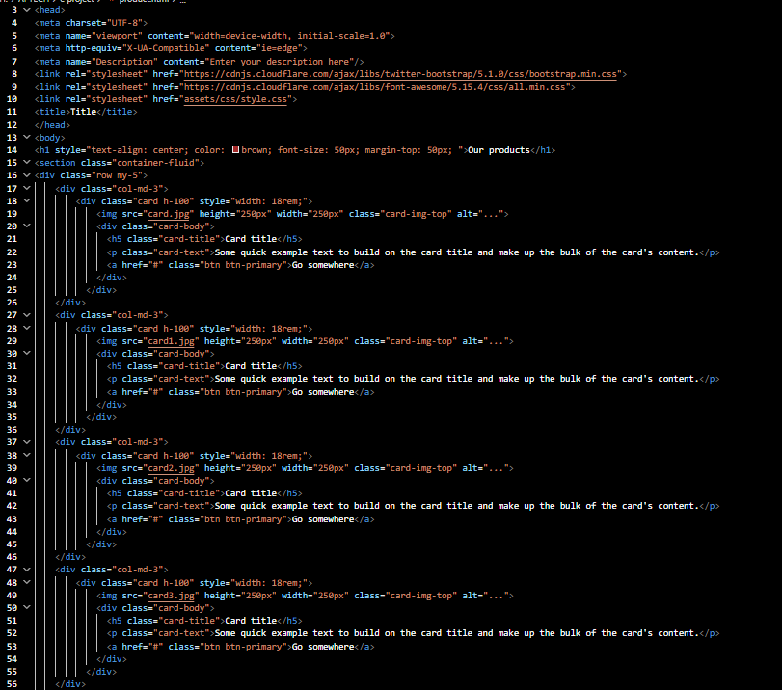

PRODUCT PAGE CODING

9

***eProject: Wilson Sporting Goods***

1. Contact us Page (**4. Contact us.html**)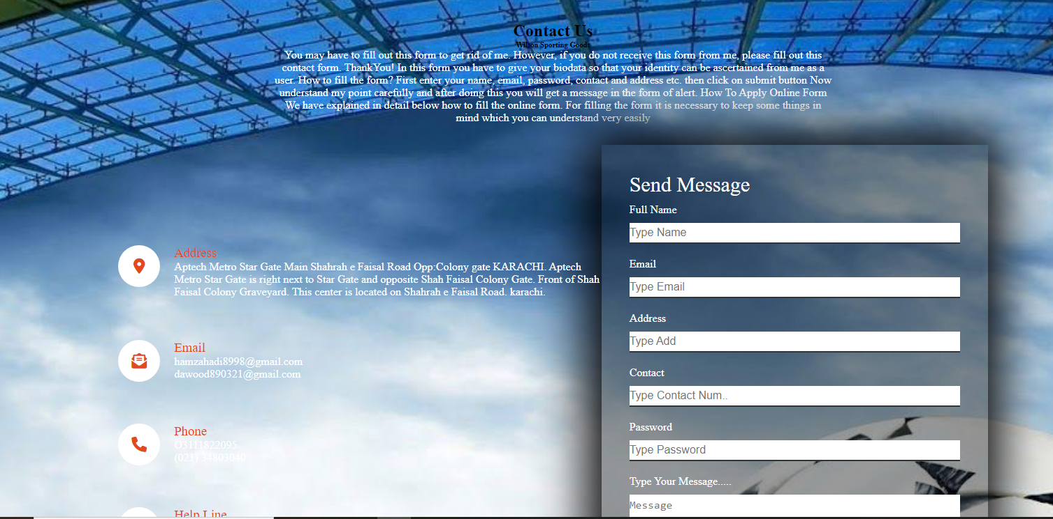

**GOOGLE MAP 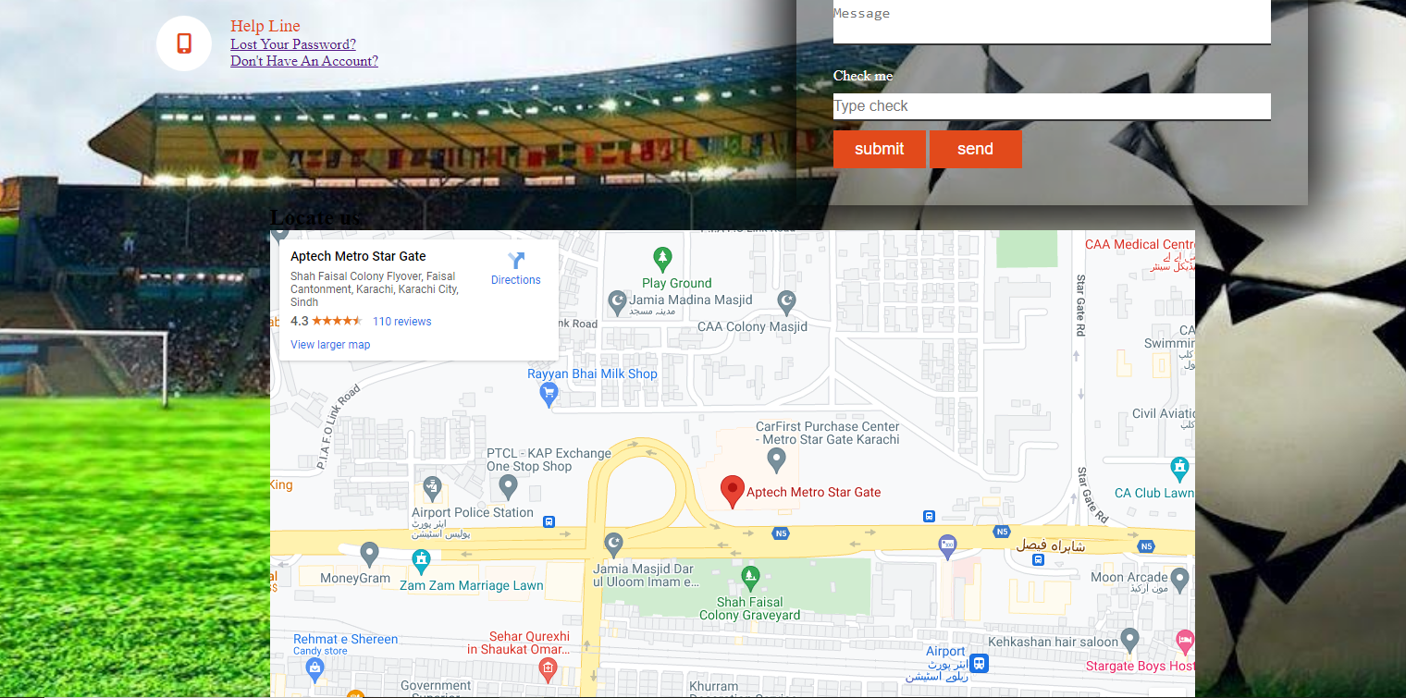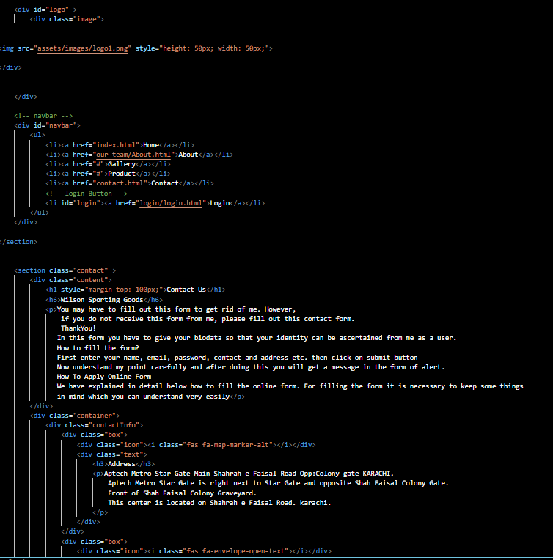CONTACT PAGE CODING**

10

***eProject: Wilson Sporting Goods***

1. Login Page (**Login.html**)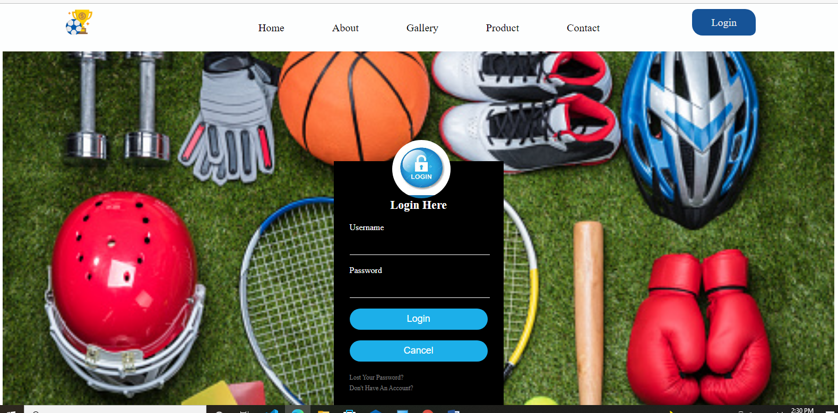

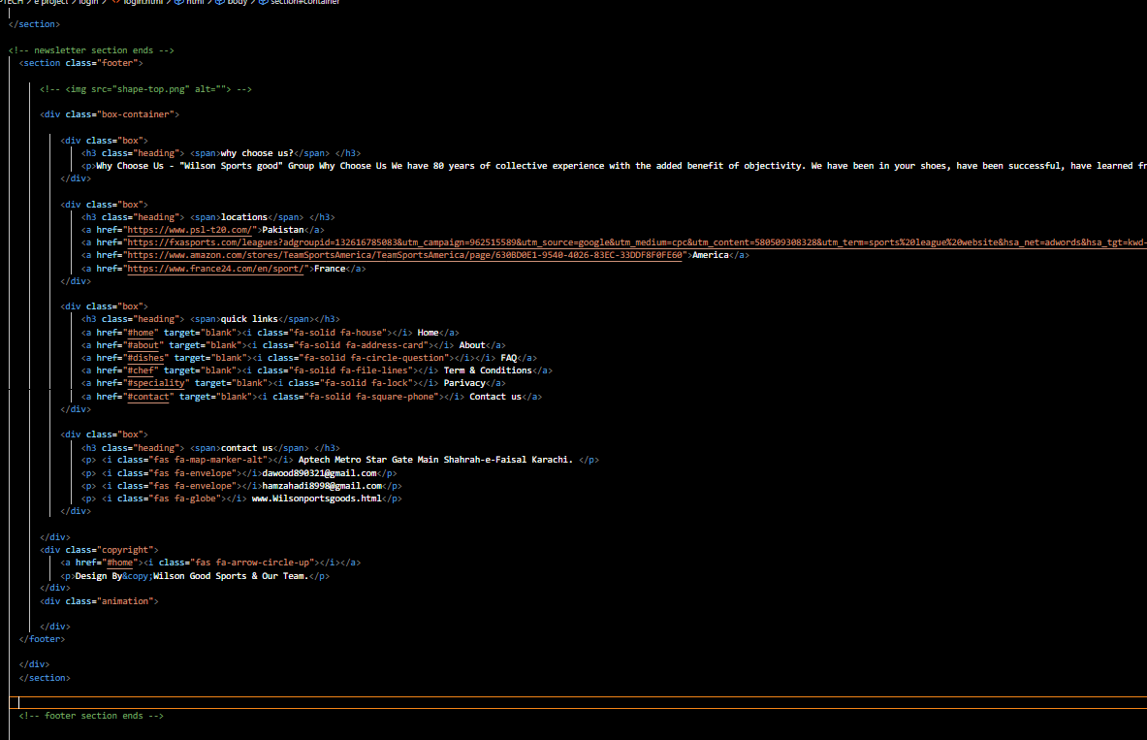

LOGIN PAGE CODINGS

***eProject: Wilson Sporting Goods***6.Register.html

12

***eProject: Wilson Sporting Goods***

TASK SHEET REVIEW 2

|  |  |  |  |  |  |  |
| --- | --- | --- | --- | --- | --- | --- |
| eProjects  Breakpoints | | Project title | Date of Preparation of Activity Plan | | | |
| No | Task | WILSO-N SPORTI-NG GOODS | Actual | Actual | Team-mate | Status |
| Start Date | Days | Names |
| 1 | Build Home | 08/FEB/22 | 1 | DAWOOD USMAN | Complete |
| Page |
| 2 | Build Product Page And  Gallery Pages and About Pages. | 09/FEB/22 | 1 | AYESHA USMAN  &  DAWOOD  USMAN | Complete |
| 3 | Build | 13/FEB/22 | 4 | HADI ABBAS | Complete |
| About,  Login, links Locator, Contact us page |
|  |
| 4 | Build Compare Page | 17/FEB/22 | 3 | HADI ABBAS  &  AYESHA  USMAN  &  DAWOOD  USMAN | Completed |
| 5 | Begin Code  JavaScript &CSS For The Home Page  &ALL PAGES | 20/FEB/22 | 2 | HADI ABBAS  &  AYESHA  USMAN  &  DAWOOD  USMAN | Complete |
| 6 | Begin Code | 24/FEB/22 | 4 | HADI ABBAS  &  AYESHA  USMAN  &  DAWOOD  USMAN | Complete |
| JavaScript & CSS  For The Product  Page And Gallery Page Login page  Contact us pages. |
|  |
| 7 | Begin Code | 01/MARCH/22 | 4 | HADI ABBAS  &  DAWOOD  USMAN | Complete |
| JavaScript and CSS & HTML all Pages. |
|  |

13

***eProject: Wilson Sporting Goods***

|  |  |  |  |  |  |  |
| --- | --- | --- | --- | --- | --- | --- |
| 8 | Begin Code Support For Browsers |  | 01/MARCH/22 | 4 | HADI ABBAS  &  DAWOOD  USMAN | Complete |
| 9 | Check Progress And Assign New Tasks | 02/MARCH/22 | 1 | HADI  ABBAS | Complete |

14

***eProject: Wilson Sporting Goods***

# TASK SHEET REVIEW 3

|  |  |  |  |  |  |  |
| --- | --- | --- | --- | --- | --- | --- |
| Project Ref. No.: eP/Advertisement Portal Management  System/01 | | Project title | Date of Preparation of Activity Plan | | | |
| No | Task |  | Actual | Actual | Team-mate | Status |
|  | Start Date | Days | Names |
|  | Check color |  |  |  |  |  |
| 1 | format, size,  JavaScript, |  | 08/FEB/22 | 1 | DAWOOD  USMAN | Complete |
|  | responsive in the |  |  |  |  |  |
|  | Home page |  |  |  |  |  |
|  | Check color |  |  |  |  |  |
| 2 | format, size,  JavaScript, responsive in |  | 09/FEB/22 | 1 | AYESHA  USMAN  &  DAWOOD  USMAN | Complete |
|  | About page and |  |  |  |  |  |
|  | Gallery and Product Page. |  |  |  |  |  |
|  | Check color  format, size, JavaScript, | Aura Watch | 13/FEB/22 |  | HADI  ABBAS |  |
| 3 | responsive in  Login, Compare, Contact us Page. |  |  | 3 |  | Complete |
|  | Footer, Navigation |  | 13/FEB/22 | 3 | HADI  ABBAS  &  DAWOOD  USMAN |  |
|  | Locator. |  |  |  |  |  |
|  |  |  |  |  |  |  |
| 4 | Write a developer guide |  | 20/FEB/22 | 7 | HADI  ABBAS  &  AYESHA USMAN | Complete |
| 5 | Write user |
| manuals |  |  |  |  |  |
| 6 | Overall inspection of the |  | 07/FEB/22 | 28 | HADI  ABBAS  &  AYESHA USMAN  &  DAWOOD  USMAN | Complete |
|  | project |  |  |  |  |

15

# Thankyou.

***eProject: Wilson Sporting Goods***